**FAQ**

**Q: My P7-C1 case’s front LEDs don’t light up. What do I need to connect?**

*A: Please check if the LED cable from the front is pre-connected. If not, please connect it as shown in photo below.*

*Secondly please make sure to connect the Molex connector to the power supply in order to activate the LED strip.*

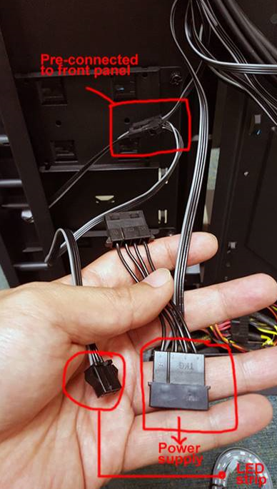

**Q: I want to remove the front panel to install/clean fans. How do I remove it?**

*A: At the bottom of the front panel, you will find a slit-like opening. Curl your fingers into the opening and pull to remove the front panel. You may need to pull with some force.*

*(Exception: P7 Series PC cases)*

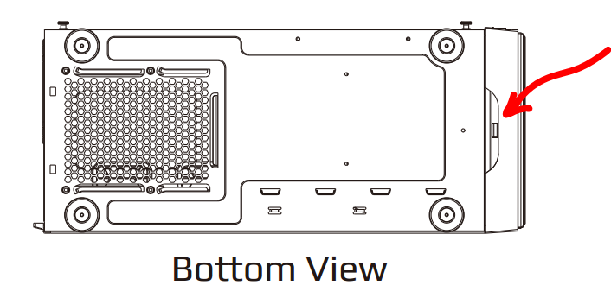

**Q: When I push the button on top of my Streak case the LED on the front panel does not change colors.**

*A: Please make sure you connected the Reset 2-pin to the LED Strip’s connector from the front panel and also connected the Molex 4-pin to the power supply to activate the RGB function.*

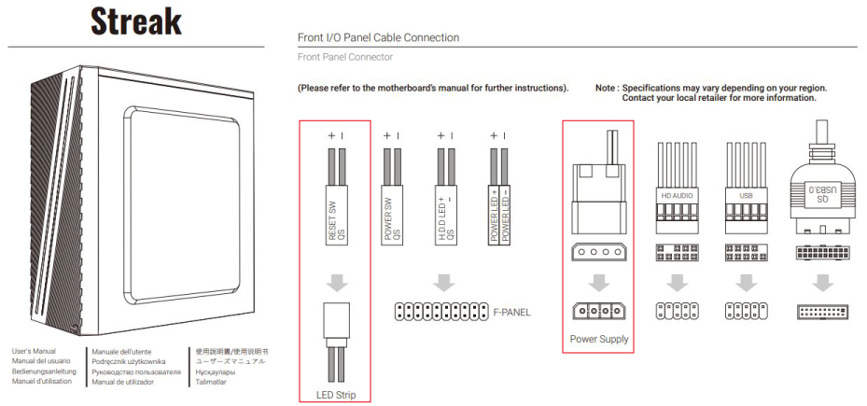

**Q: I have connected all cables but the LEDs on the front panel don’t light up?**

*A: Please make sure you connect the SATA cable to the power supply in order to activate the LED function.*

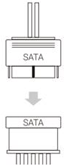(Models: Cylon, Playa, Aero-500G RGB, Bolt, Bolt Mini,…)

**Q: I have a Quartz Pro case. How do I switch off the rear LED I/O light?**

*A: Please disconnect the Molex 4-pin connector to disable the rear I/O LED light.*

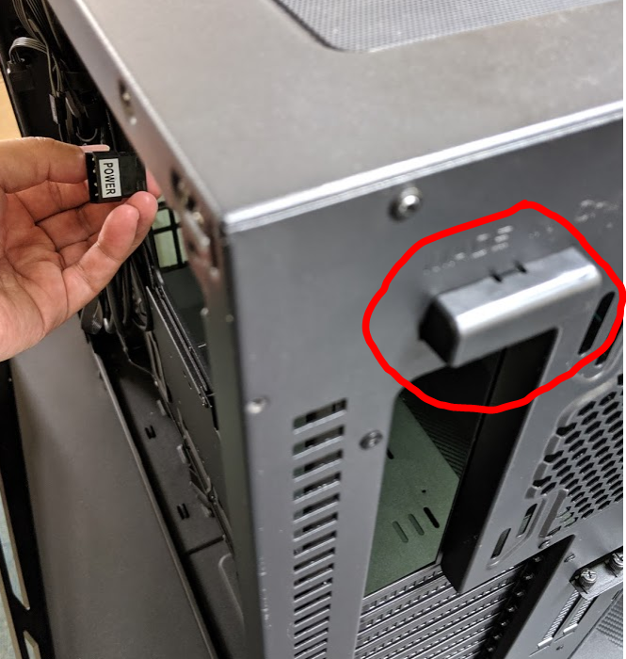

**Q: How do I install 240mm AIO liquid cooler in Cylon case?**

*A: Unfortunately The Cylon case supports only 120mm AIO on the front panel.*

**Q: The tempered glass on my case is shattered (or cracked) )and it is still under warranty. What do I?**

*A:*

*1. Please prepare proof of purchase*

*2. Take a photo of the broken glass with the case (AeroCool logo must be visible)*

*3. Describe in detail what caused the broken glass (Eg. while removing/installing the tempered glass / hit by other object / arrived cracked or broken)*

*4. Email the above info to …………….*

**Q: What will happen if I make modification to the AeroCool PC case?**

*A: We do not recommend making modification to the case. In doing so, you will be breaching the warranty. If any damage to the case after you made modification to it of any kind, the warranty will become void.*

**Q. Where are the screw holes to install a 12cm fan on the top panel of Cylon case?**

*A: Please use the elliptical holes to fasten a 12cm fan.*

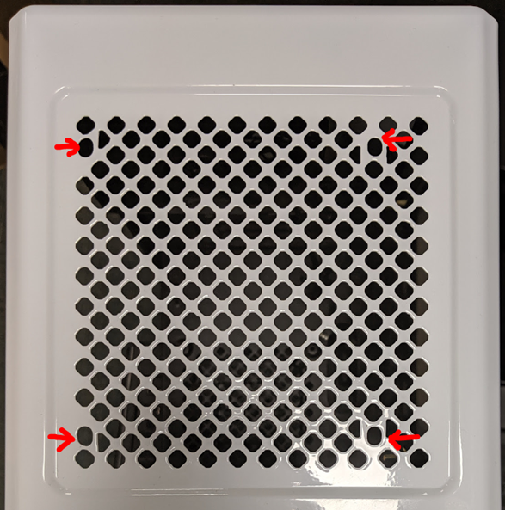

**Q: The LED next to power button is flashing on and off (flickering). Is this normal?**

*A: The other end of this LED cable is connected to the “HDD” header on the Motherboard, so the flickering indicates that your HDD is working (computing in progress).*

**Q: Can I control fan speed with the P7-S1 software?**

*A: Unfortunately this software only allows you to monitor fan speed, not to control it.*

**Q: What are the fans installed in these case and where can I buy them:**

A*: 1. Klaw: Eclipse fans.*

*2. Tor: Edge fans*

*3. Tor Pro: Edge fans*

*Please consult with your local dealers for where to buy.*

**Q: I cannot connect my Addressable RGB cable/s to the Motherboard. Why?**

*A: Some motherboard models only provide standard RGB connection (4-pin) and not the Addressable RGB connection (same connector as 4-pin but with one pin missing).*

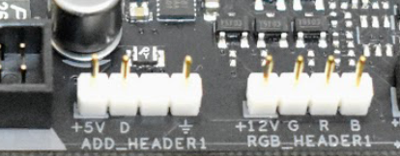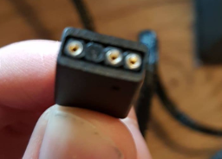

**Q: There is only 4-pin RGB header on my motherboard. Can I use a splitter to connect to my Addressable RGB fans?**

*A: Unfortunately you cannot. The technologies are different between the two.*

*On the regular +12V RGB header, all LEDs of a primary color (R, G, B) are chained together and act simultaneously depending on the input signal. This makes individual LED addressing impossible.*

*On the +5V RGB header, there appears to be a LED driver IC for each RGB LED package that translates the serial information coming in through the data pin into a specific output for that LED package it is attached to. That method makes single LED addressing possible.*

**Q: How do I connect the 2-pin connectors from the case’s I/O to my Motherboard?**

*A: Please refer to your Motherboard’s user’s manual. It contains detailed illustration on how to connect them.*

**Q: Can you provide circuitry diagrams?**

*A: Due to company policies, we do not provide circuitry info or diagrams to the public.*

**Q: I have an Orbit RC fan set. Is it possible to connect it to RGB addressable Motherboard?**

*A: Unfortunately the Orbit RC is a closed system design. It can only be controlled by the remote controller that it came with.*

**Q: How do I remove fan blades for cleaning?**

*A: You can push the fan blades out from the back of the fan.* ***<Internal memo: Check Product page before posting this. Not all fan blades are removable.>***

**Q: Which is the correct way to install power supply? The fan facing down or facing up?**

*A: All PC cases are compatible with power supply installed in either way. The decision is really depending on the internal layout of your case.*

*If the PSU compartment is located at the bottom of the case, then you will want to have your PSU fan facing the floor, so that the air it takes in is colder than the air up above. (Almost all today’s cases in the market are of this internal structure)*

**Q: My case temperature is very high but the smart fan control feature on my PSU did not trigger the fan to spin?**

A:

**Q: Pulse-L240 liquid cooler. The little green fan (Flow Indicator - not electrically connected) sometimes spin and sometimes do not spin?**

*A: The cable coming out from the pump is a 4-pin PWM connecter, so sometimes when the CPU is not under heavy load (idle) the BIO will reduce the RPM speed of the pump.*

*Under this condition, the coolant inside the system may flow slower and therefore the force is not strong enough to push the blades in the Flow Indicator, so it may seem the pump is not working, nevertheless the entire cooling unit is still working to cool the CPU.*

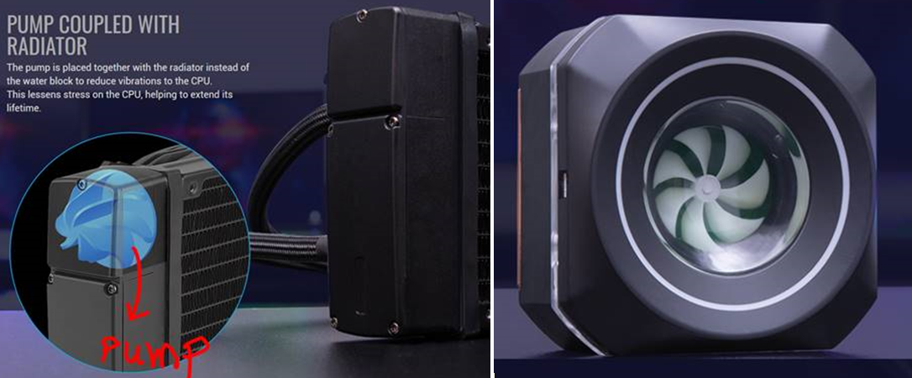

Q: Fan controller - The thermal sensor (or Thermal probe) is not detecting temperature. I want to replace the sensor. What is the model of the sensor?

A: NTC-103AT

**Q: The power cuts off suddenly in the middle of my gaming session.**

A:

**Q: What kind of PSU should I choose for minning?**

A:

**Q: The modular cable on my PSU melted.**

A:

**Q: How to keep my chair clean? How to clean my chair? What should I use to clean my chair?**

A:

**Q: where I can buy a remote control for my orbit fans?**

A:

Q: How much to refill for P7-L240?

A: Capacity is around 250ml. Please make sure of the following:

- When adding coolant, ensure your system is powered off and no electronic parts are placed around the cooler.

- When refilling the coolant please observe there are no major bubbles in the reservoir.

- Please use dedicated coolant or distilled water.

**Q: My _________ is not working.**

*A: Did you check your cables? Make sure everything is plugged in. Check your power cables. Can we make a checklist for people to go through to check their details? Example: Case - checklist. PSU: Checklist. Cooler: Checklist.*

***Q: Can I connect two hubs together to have 9 fans or more synced? Example: I have 9 Eclipse 12 Pro RGB fans but I can only connect 6 to the H66F Hub. I would however like to buy a second hub, to do a multiple hub connection by adding the second Hub Add rgb port to the first one. Would this be a possibility in order for me to have all the 9 fans providing the same lighting as my MOBO only has one Add_rgb port?***

*A: You can connect HUB 1 to MB and HUB 2 to ADD_RGB of HUB 1 to synchronize all fans.*